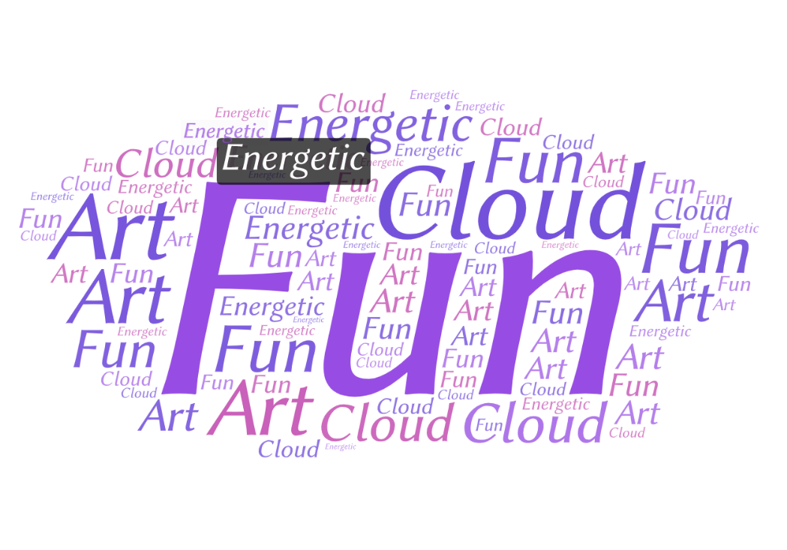I used two tools called EdWordle and WordArt. EdWordle was a little more user friendly because it allowed input text or the ability to format an existing cloud. Some of the functionality included different colors, different fonts, the ability to move, rotate, add and delete words. WordArt allowed similar capabilities but you had to type in individual words. Overall I would recommend EdWordle to a friend and will use in the future for word clouds.